PBI for Monday boards.PBIX

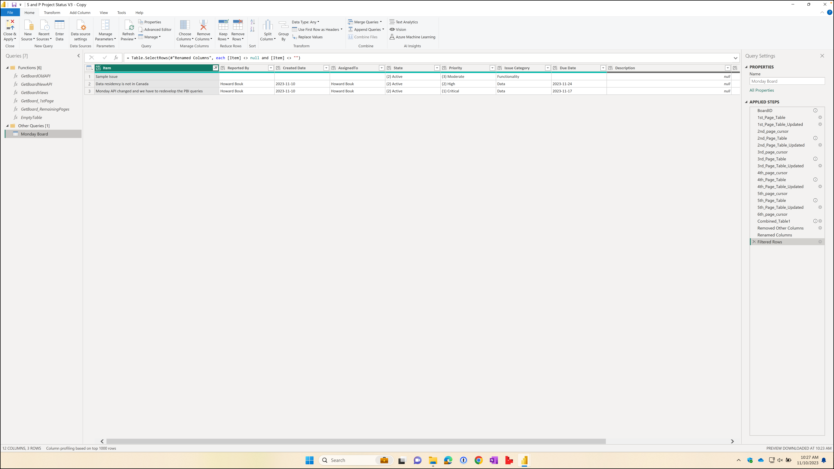

Figure - Query Editor showing functions and queries for retrieving a Monday.com board

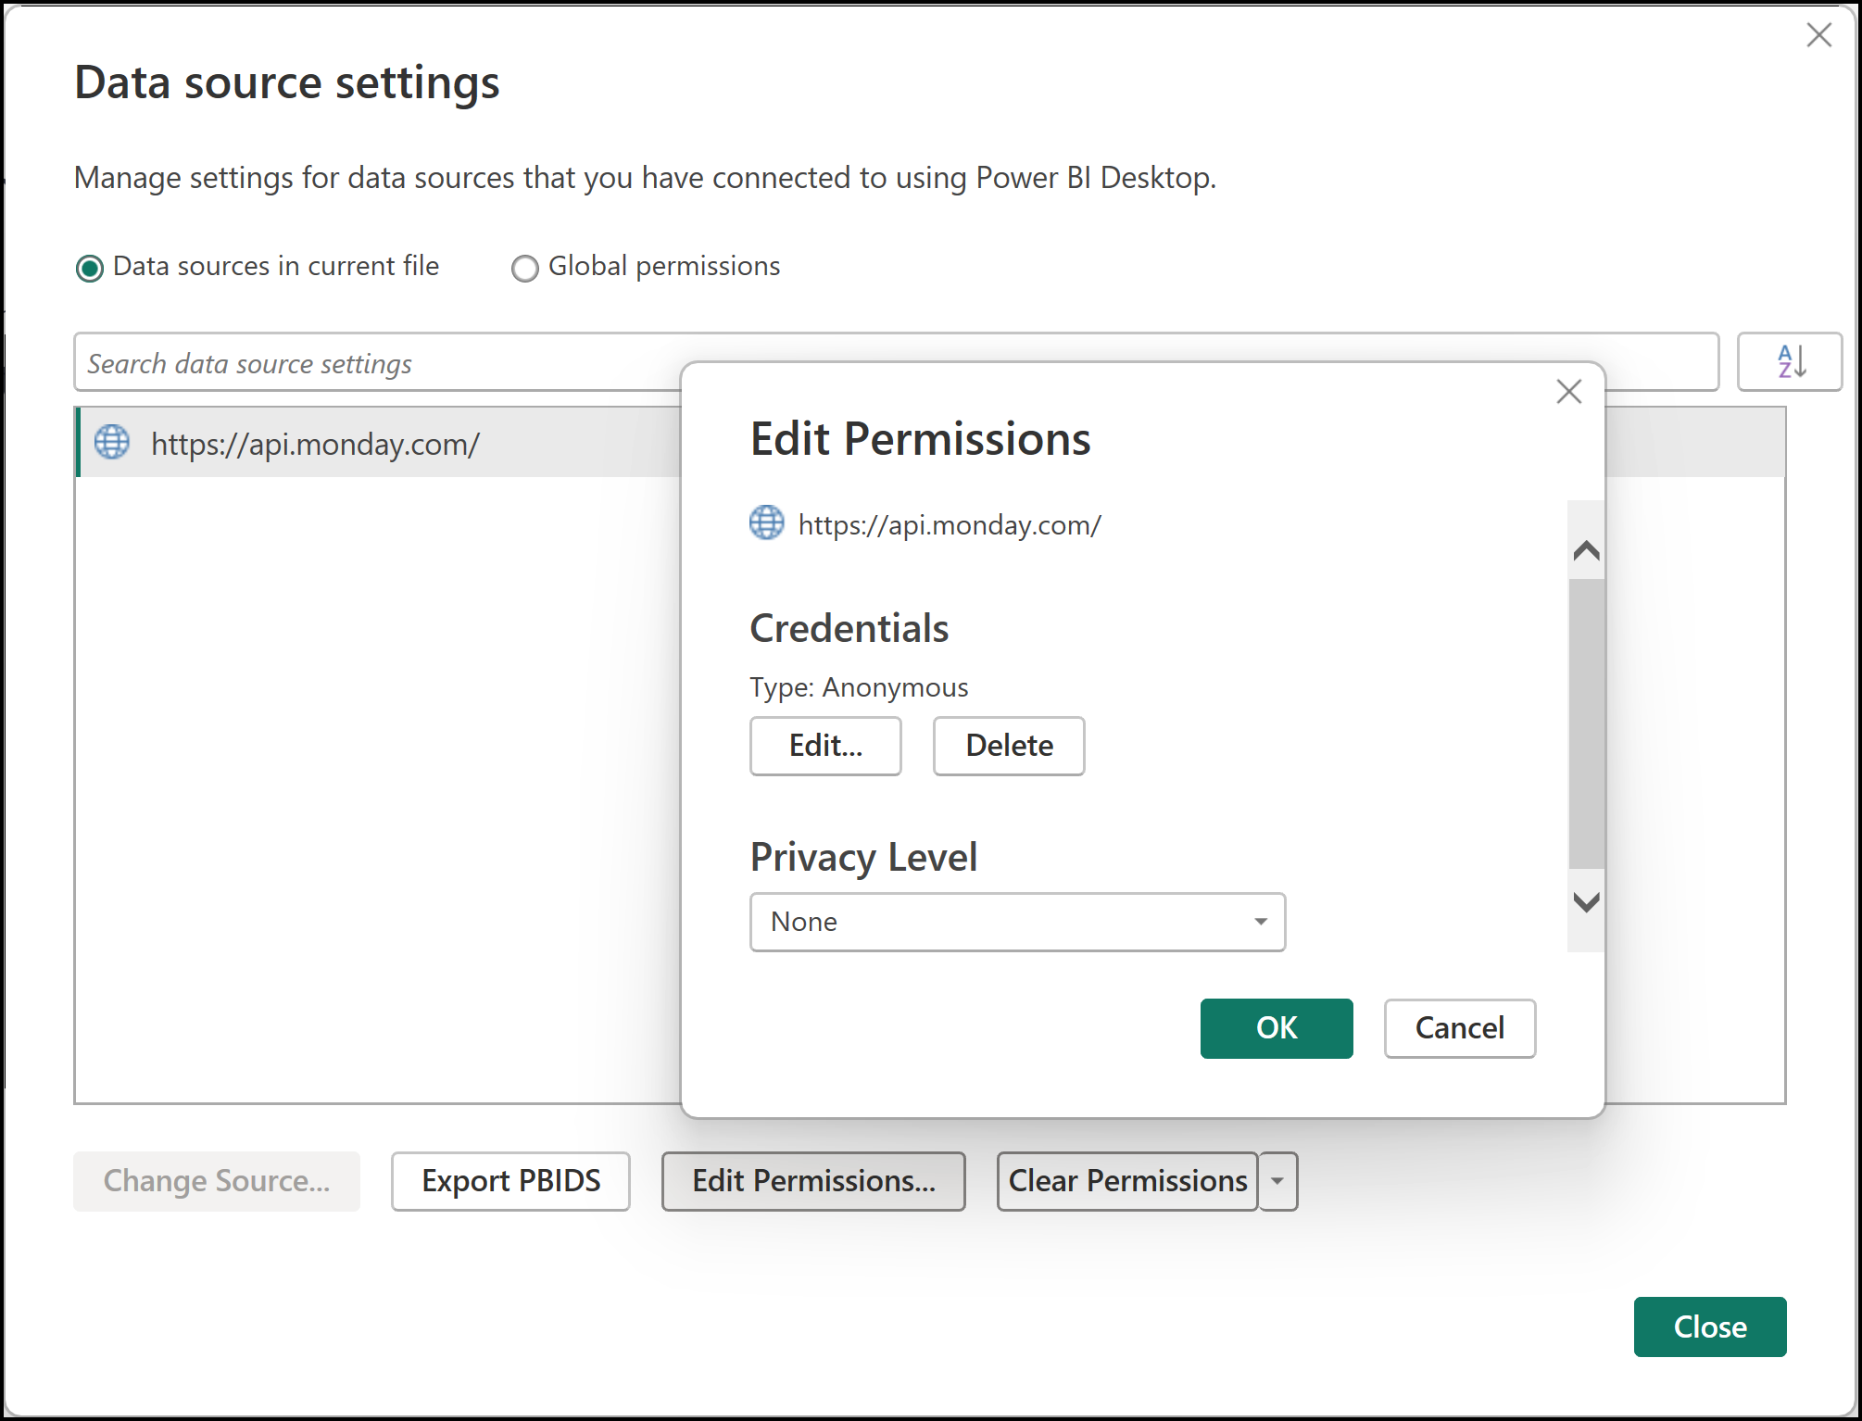

Figure - Data Source Permissions to connect to Monday.com

Using the sample PBIX file

1. Open the PBIX file then click on Transform Data button
2. Update “Authorization” key using the Advanced Editor in the GetBoardOldAPI, GetBoardNewAPI, GetBoardViews, GetBoard_1stPage, GetBoard_RemainingPages functions (Figures 3, 4,
3. Test the GetBoard_1stPage function by providing a board number then clicking the invoke button
4. Update the EmptyTable function using the Advanced Editor so that the column names match with the column names in your board
5. Update the Monday Board query using the Advanced Editor to update the board number and column names

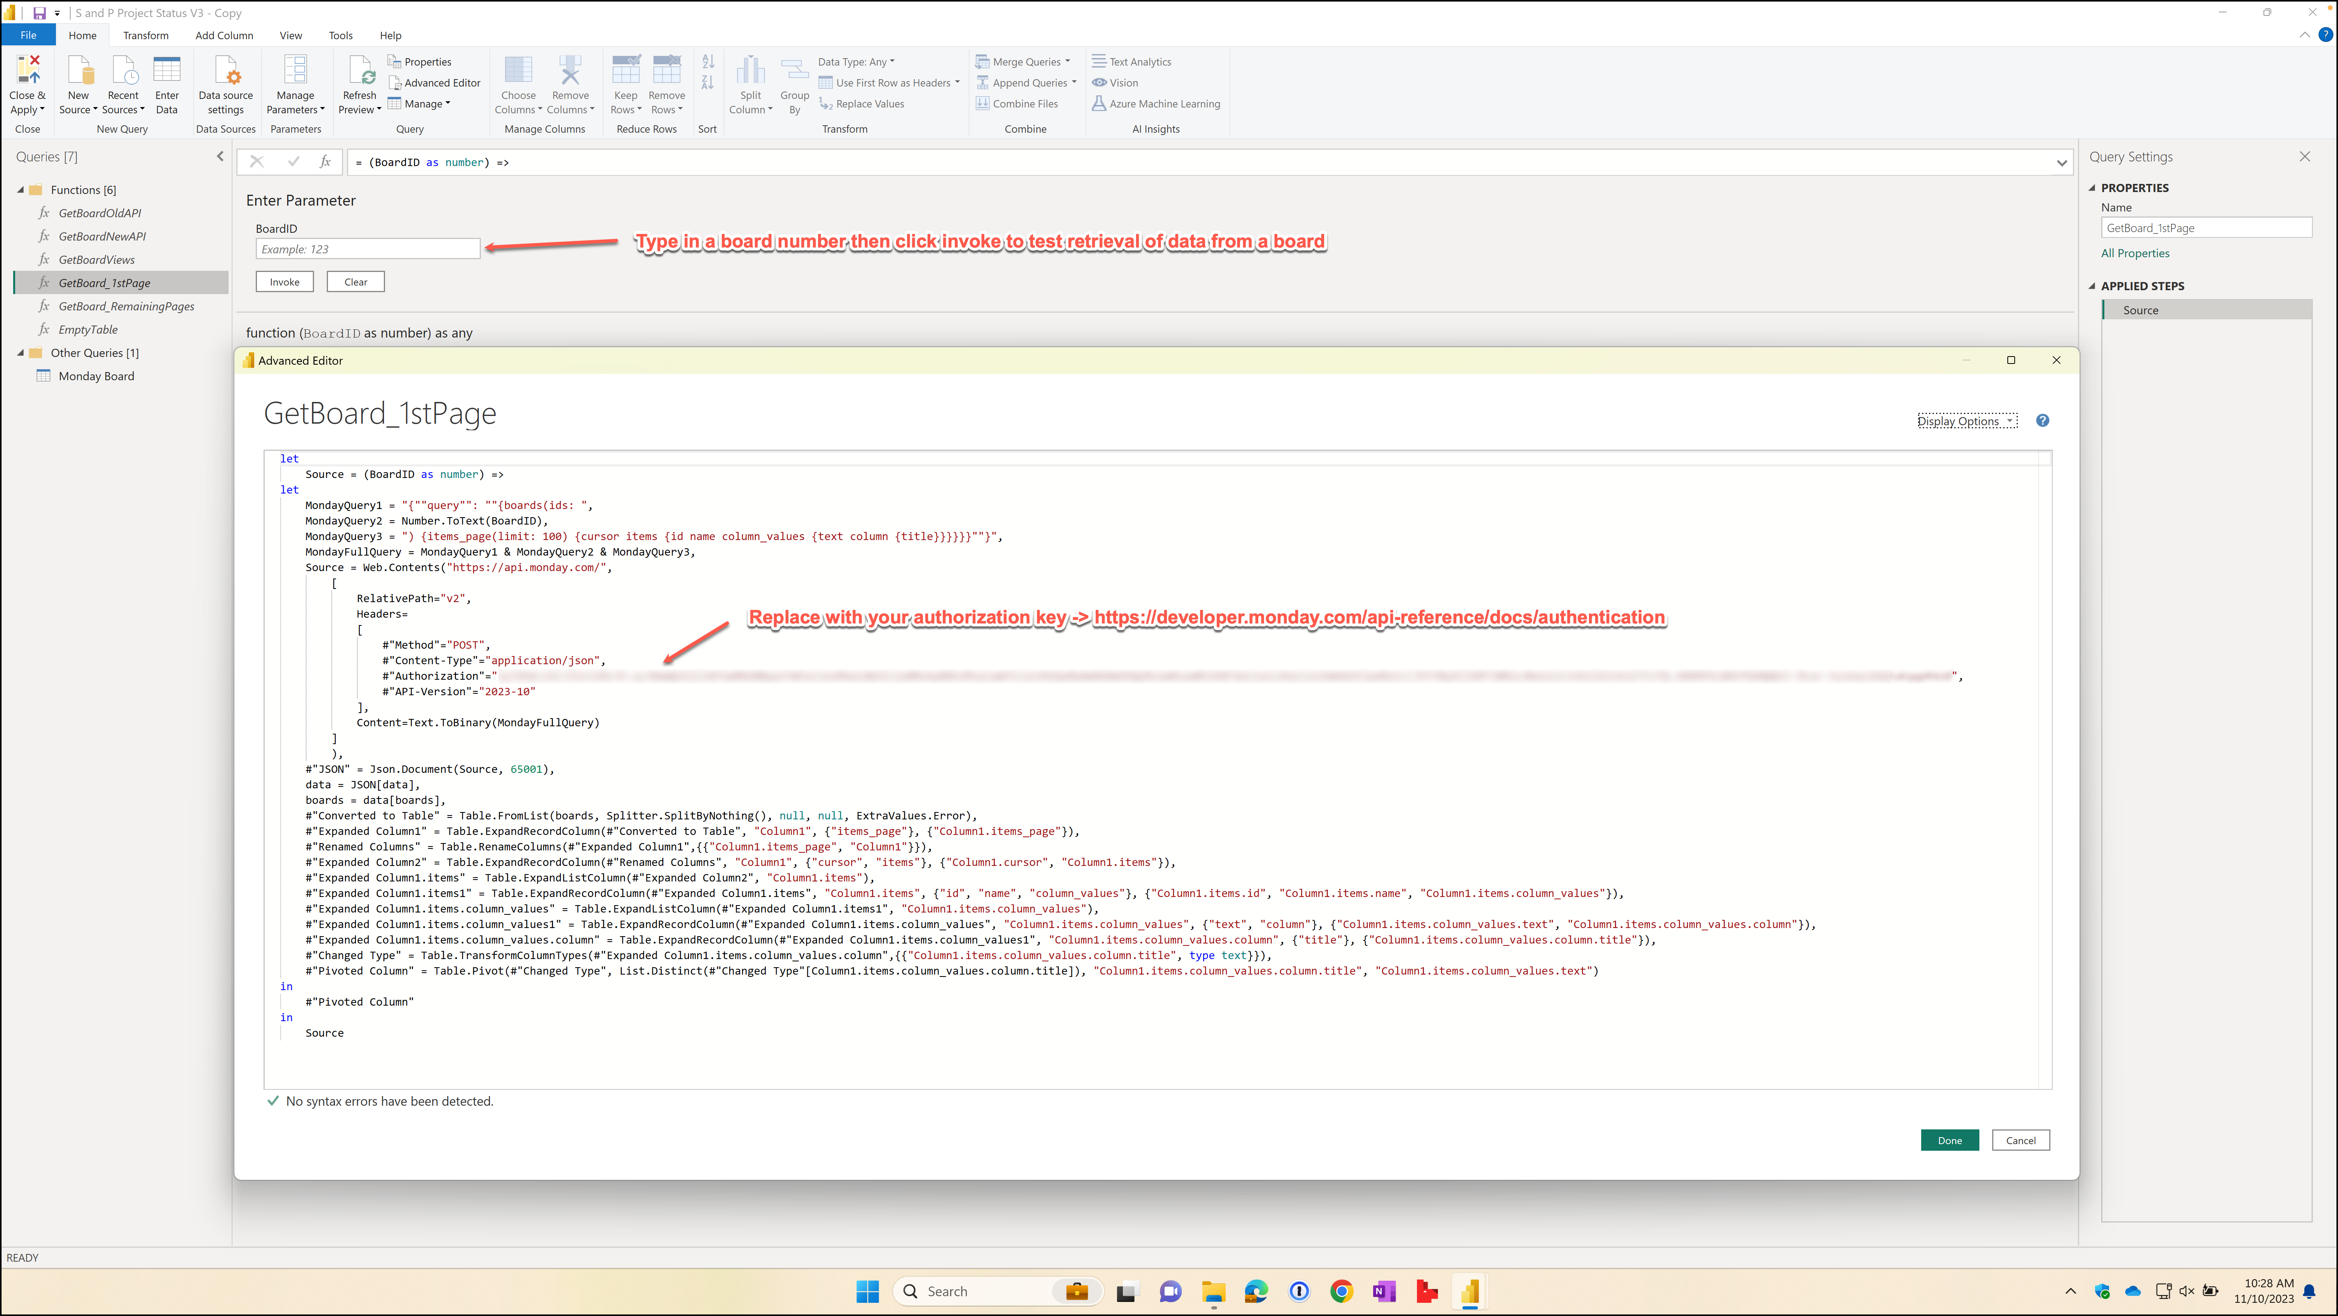

Figure - GetBoard_1stPage function

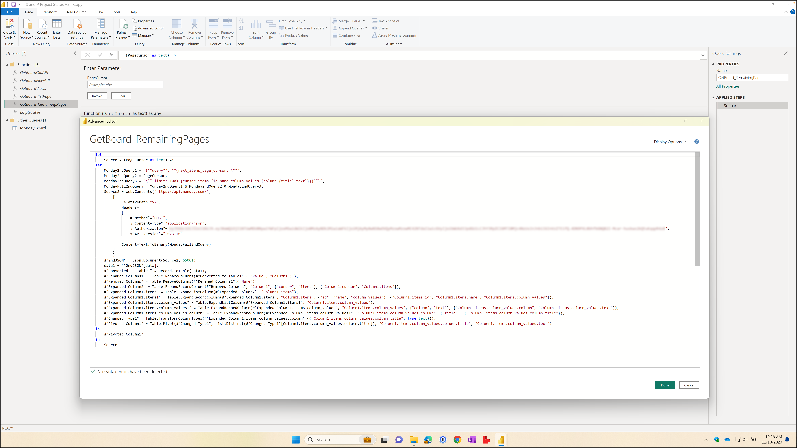

Figure - GetBoard_RemainingPages function

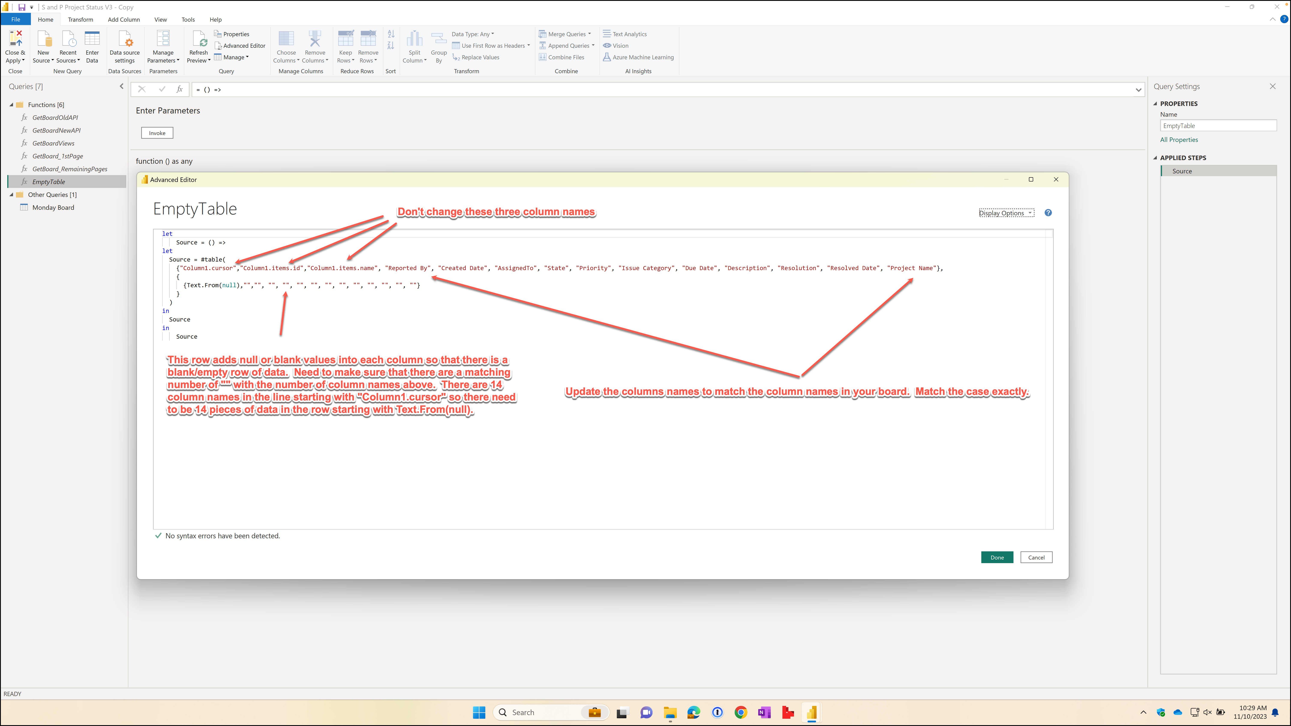

Figure - EmptyTable function

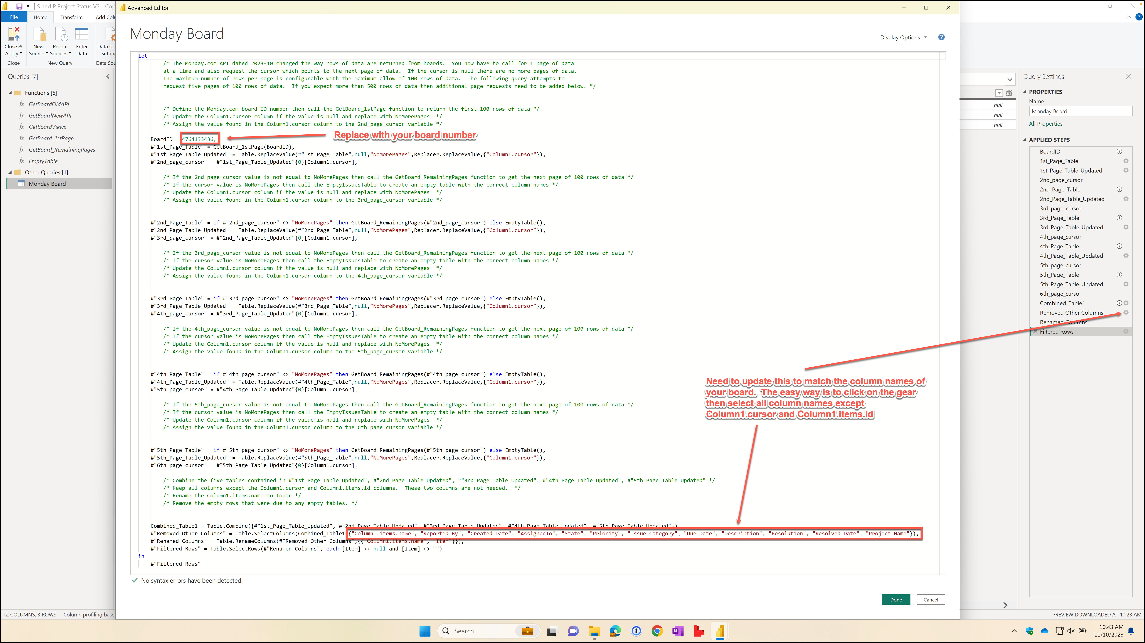

Figure - Monday Board query

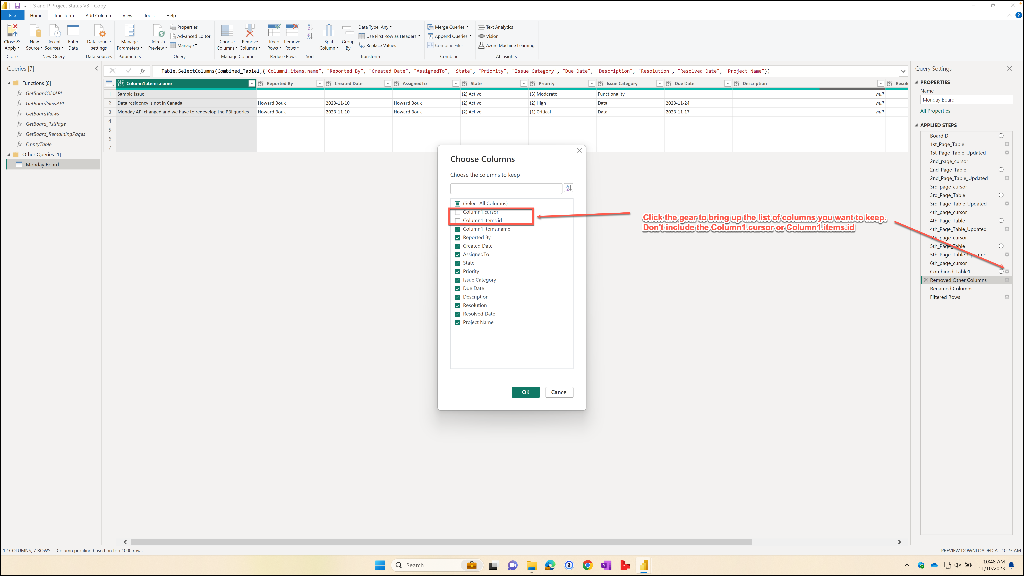

Figure - Monday Board query – updating the columns to keep

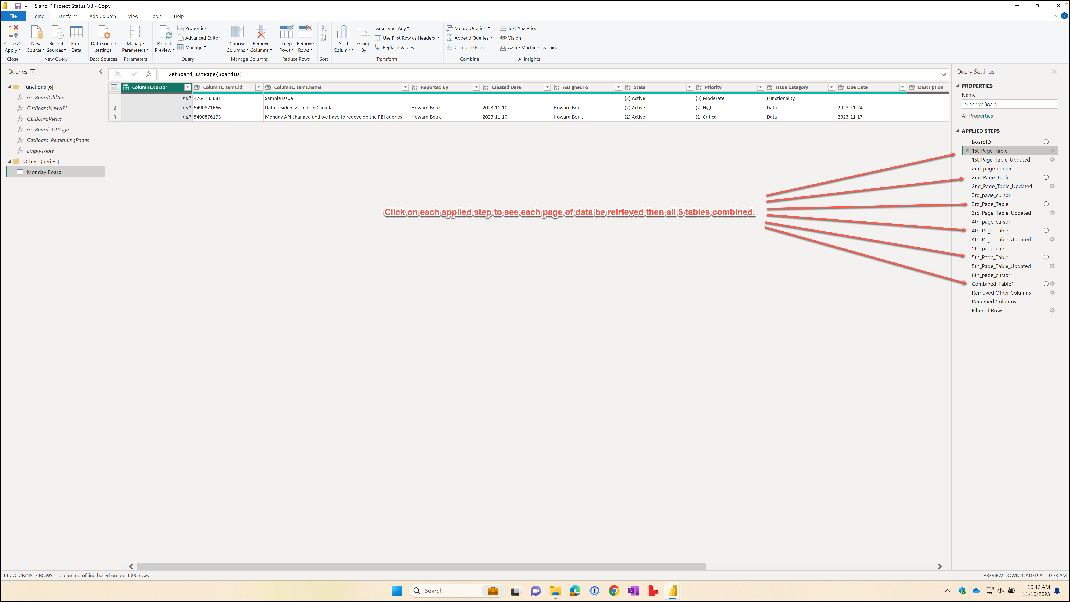

Figure - Monday Board query - click on applied steps to step through creation of the final table